**QUESTION NO 01:**

**Task # 01:** Create following two tables:

**Table Name:** Department

**Column 1:** Dept_Id (Auto Number) PK

**Column 2:** Dept_Name (Short Text)

**SOLUTION:**

**Table For Department:**

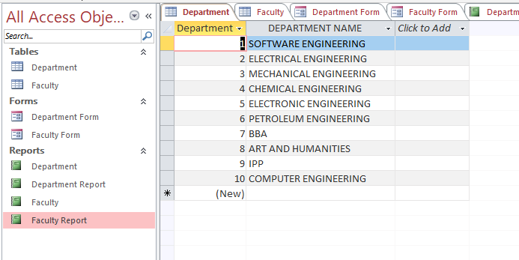

**Task # 02: Create a form for inserting Department and their respective Faculty details in Access Database .Table Name: Department.**

**Form for department:**

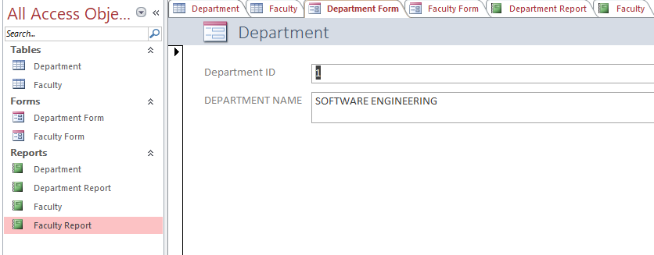

**Task # 03: Create report of the given database.’’**

**Report for Department:**

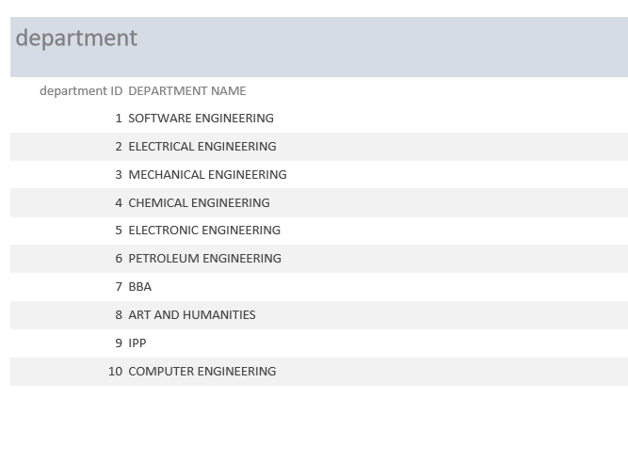

**QUESTION NO 02:**

**Task # 01:** Create following two tables:

**Table Name:** Faculty

**Column 1:** Faculty (Auto-number) PK

**Column 2:** Name (Short Text)

**Column 3:** Contact No (Number)

**Column 4:** Dept_Id (Number)

**SOLUTION:**

**Table For faculty members:**

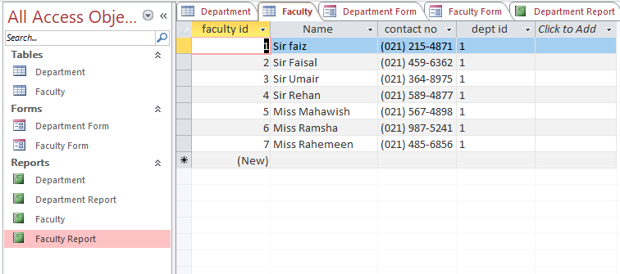

**Task # 02:** Create a form for inserting Department and their respective Faculty details in Access Database. **Table Name:** Department.

**Form for faculty members:**

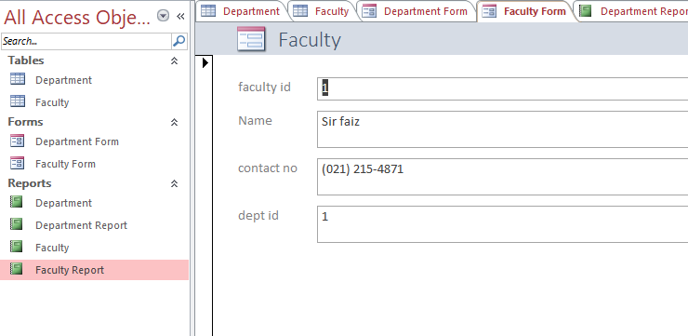

**Task # 03:** Create report of the given database.’’

**Report For faculty members:**

